

Sensitivity Analysis of an Electrical Machine using femm4.2

Pawan Kumar Dhakal [20316641]

[eexpd6@nottingham.ac.uk]

# Introduction

Over the decade, the rise of PMSM has been rapidly high because of their high-power density, high torque density, high temperature stability, because of their ability to work under corrosive environment etc. Permanent magnet machines have wide range of applications such as aerospace, home appliances, automotive etc. In modern more-electric aircraft concept, aircraft actuation system is using permanent magnet machine as they are best match for the job. One of such kind of machines are Surface Mounted Permanent Magnet Motors (SPM). Design of electrical machine from scratch is always challenging. One of the best design approaches is to carry out some preliminary design using analytical equations and finally analyzing using Finite Element Method (FEM) with software like FEMM. We can often use iterative algorithms in preliminary design as they are lengthy and time consuming. Based on already available data or utilizing similar work experience, the analytical design is prepared with analytical equations and then this will be fine-tuned using various analytical software in detail before validation [1-7].

With evolution of sustainable solutions like electric vehicles in the automotive field, the efficient design of traction motors which can power the wheels with high efficiency, high power density, high torque, which is cost effective, and has wider operating range. Although induction machines are already proving of being lower cost, used in various applications, easy to construct and reliable, permanent magnet motors are becoming popular because of their various advantages as already mentioned above. As electric vehicles operate over wider torque-speed ranger with variable driving condition, the permanent magnet machine needs to be designed to have a total energy saving over a driving period. The EV’s weight and the cost are basically related to the driving range and the battery capacity. There is a tradeoff between the energy efficiency and the static efficiency at rated power over a driving period [6-13].

Brushless PM drive systems are potentially evolving in the field of automotive both in hybrid and electric vehicle applications. Major advantages of brushless permanent magnet motor are high peak to continuous torque and power and they are best suitable for urban electric vehicle application. A design methodology is described in [14] for a linear electromagnetic model to determine main geometric dimensions, terminal parameters, inductance, and resistance. It also verifies the thermal performance of the lumped parameter model and the design methodology is validated using finite element analysis (FEM). Although, high speed motor seems to be a better solution, if we consider the parameters like gear ratio technology and the efficiency, high torque motor is the better choice. The driving frequencies of the cogging torque are majorly dependent on the pole number and the slot numbers. The tangential reluctance due to circumferential airgap between the permanent magnet segments, generates the harmonics to the cogging torque. If we use rubber magnets between the airgaps, the reluctance variation between the airgap can be reduced [15-20].

# Objective

The objective of this coursework is to do the sensitivity analysis of the Surface Mounted Permanent Magnet Motor (SMPMM) with preliminary design specifications from the coursework 1 using Finite Element Analysis (FEA) software femm4.2. The aim is to analyze terms like airgap flux density, torque ripples, cogging torque, and losses and try to minimize them. The idea is to see if we can improve the overall performance of the machine with slight variations on the machine parameters intelligently.

# Design Specifications

Table 1 below shows the initial motor design parameters obtained from preliminary design that was carried out in coursework 1. These parameters are considered as initial parameters and are used in initial finite element tests. Since, the **diameter to length aspect ratio is small**, any **3D effects** are neglected while doing the 2D Finite Element Analysis.

Table 1 Initial Design Parameters of SPM Motor

|  |  |
| --- | --- |
| **Motor Parameters** | **Values** |
| Rated Power | 150 Kw |
| Rated Torque | 150.7 Nm |
| Peak Current | 360 A |
| Base Speed | 9500 RPM |
| External Diameter | 219 mm |
| Stator Inner Diameter | 160 mm |
| Stack Length | 165 mm |
| Pole Pairs | 4 |
| Slot Numbers, Slot Height | 72, 15 mm |
| Tooth Width | 3.3 mm |
| Slot Opening Height, Width | 0.8 mm, 2.5 mm |
| Wedge Height | 0.8 mm |
| Airgap Length | 1.2 mm |
| PM Thickness, Span | 2.1 mm, 0.83 |
| Filling Factor | 0.45 |

# Finite Element Analysis (FEA), Results & Discussions

To analyze the quantitative characteristics of the designed machine in coursework 1, a **2D Finite Element Analysis (FEA)** is adopted. At start the initial parameters of the machine are tested in **femm 4.2** software for the airgap flux distribution. The airgap flux distribution for full load and no-load conditions are tested. The flux line distribution and flux density plot are shown in figure 1 below at no-load condition. When the **current is zero**, we are on the no-load condition and airgap flux distribution is **symmetrical** as shown in figure 2 below. It is sinusoidal in nature as expected and the various notches in the waveforms are due to the flux variations across the stator slots. It confirms the **pole configurations** and the **maximum airgap flux density**. Of course, as the current is zero, the torque produced by the machine is **zero**.

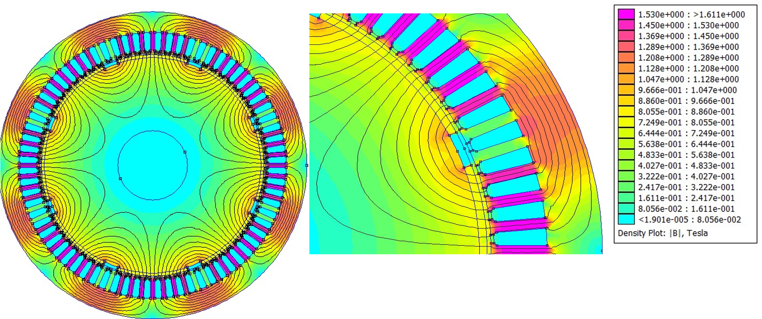

Figure 1: Flux Lines Distribution and Flux Density Plot from FEA (No Load Condition)

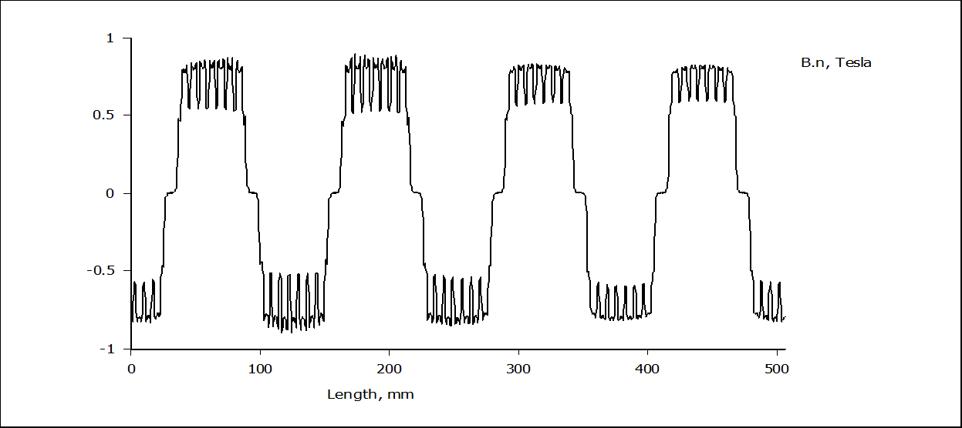

Figure 2: Airgap Normal Flux Density Plot (No Load Condition)

The general torque equation of a synchronous machine in dq frame is given by,

$$T = \frac{3}{2}p[(L_{d}-L_{q})i_{d}i_{q}+λ_{PM}i_{q}]$$

Where $L_{d}$& $L_{q}$ are the inductances of d and q-axis respectively, p is the number of pole pairs, $λ_{PM}$ is the flux linkage of the permanent magnet, $i_{d} \& i_{q}$ are the currents in d and q-axis, respectively. The equation presents the two components, the reluctance component and the component produced by the permanent magnets. The reluctance component is,

$$T_{rel}=\frac{3}{2}p[(L_{d}-L_{q})i_{d}i_{q}$$

It is clear from the above equation that, higher the difference between $L_{d}$& $L_{q}$, higher the reluctance torque. The term saliency ($ξ)=\frac{L_{d}}{L_{q}}$, defines the reluctance torque value. Higher the saliency, higher the torque. Since the machine considered in our design is a Surface Mounted Permanent Magnet Motor (SMPMM). So, it is a non-salient machine. This means, the reluctance torque component is **zero**. The torque component produced by the permanent magnet is given by,

$$T_{PM}=\frac{3}{2}p[λ_{PM}i_{q}]$$

We can clearly say that the torque produced in a SPM machine is directly proportional to the PM flux linkage and the q-axis current. In the following few pages, the effect on the airgap flux distribution and flux densities are analyzed for different conditions. The current in positive d-axis is called the **magnetizing current**. The flux density plot and the airgap flux distributions are shown in figure 3 & 4 respectively when we supply the magnetizing current. This happens when current angle is **zero**. The fundamental peak airgap flux density increases. When the current angle becomes 180 degrees, the d-axis current is negative (also called as demagnetizing current), and the q-axis current is zero. For this case, the flux distributions and density plots are shown below in figure 5 & 6, respectively. As expected, the fundamental peak airgap flux density decreases and there are more variations of flux across stator slots. It is **less smooth**.

As we have seen from the torque equations above, when the q-axis current is zero, irrespective of the d-axis current (which is responsible for the field only), the torque produced by the machine is **zero**. This has been tested and verified in **femm 4.2**.

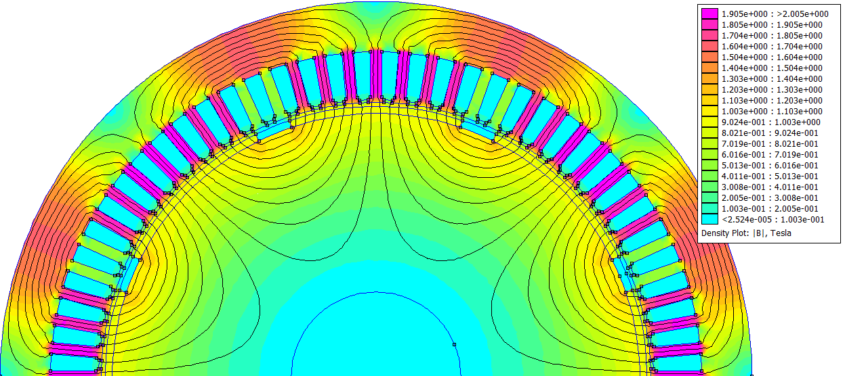

Figure 3:Flux Lines Distribution and Flux Density Plot from FEA (With Magnetizing Current Id Only, Current Angle=0)

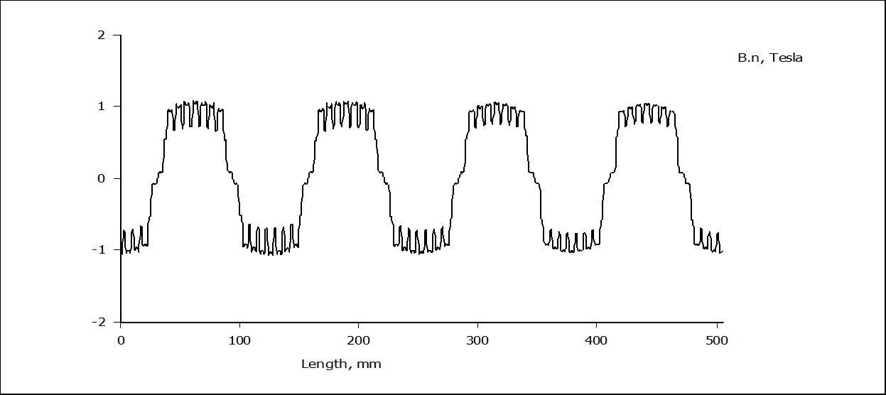

Figure 4: Airgap Normal Flux Density Plot (With Magnetizing Current Id Only, Current Angle=0)

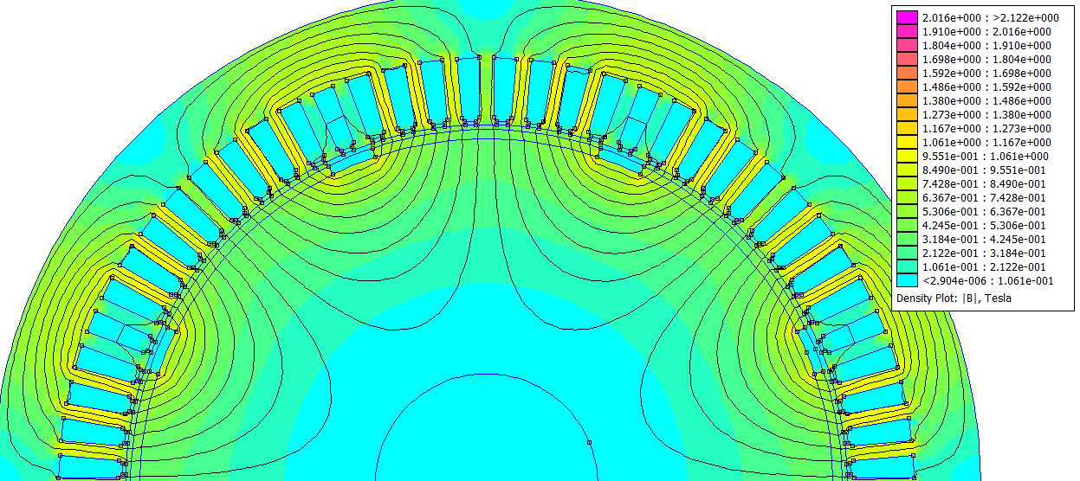

Figure 5:Flux Lines Distribution and Flux Density Plot from FEA (With Demagnetizing Current -Id, Current Angle=180 deg)

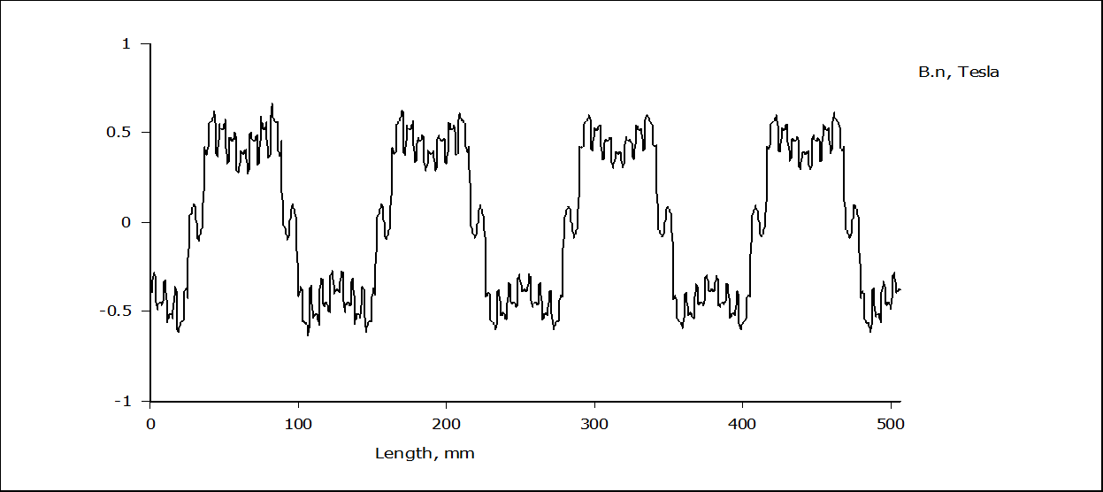

Figure 6: Airgap Normal Flux Density Plot (With Demagnetizing Current -Id, Current Angle=180 deg)

Now, let us test the machine by supplying the load current (Iq) only. This happens when the current angle is 90 degrees. The flux lines distributions and the airgap flux density plot are shown below in figure 7 & 8, respectively. The stator conductors are supplied a full peak current of **356 A**. As seen in the figure 8 below, the airgap flux density plot has been changed. It looks like the flux values are rotating sinusoidally. Slowly increasing from zero to maximum across the stator slots, not like before, when there was only d-axis current.

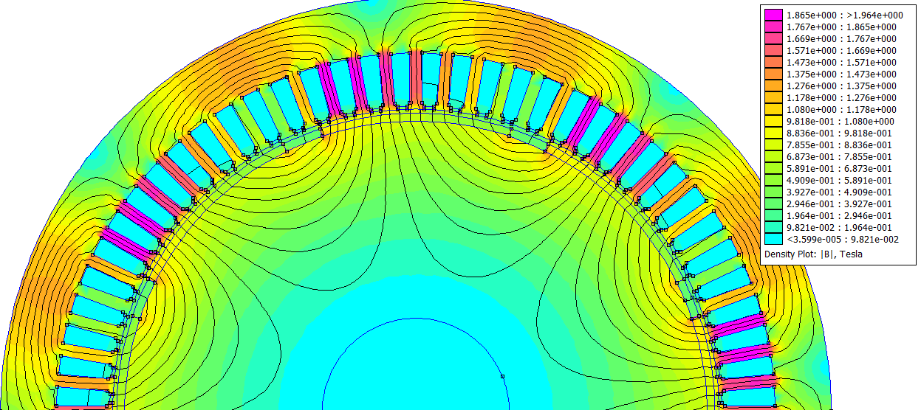

Figure 7: Flux Lines Distribution and Flux Density Plot from FEA (With Q-Axis Current Iq Only, Current Angle=90 deg)

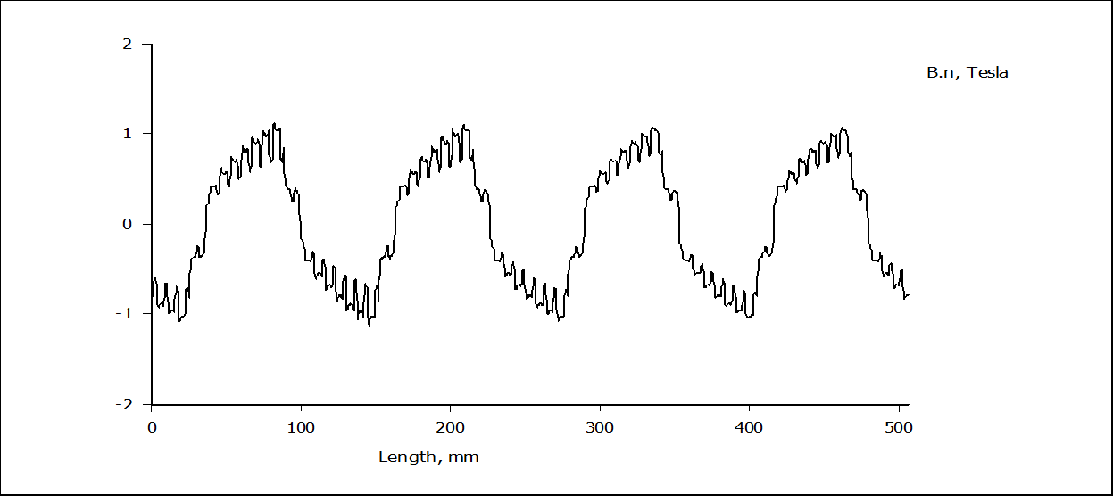

Figure 8: Airgap Normal Flux Density Plot (With Q-Axis Current Iq Only, Current Angle=90 deg)

Obviously, when we supply the rated current is q-axis only, theoretically, there should be rated torque produced in the machine with current angle 90 degrees. With conditions above, the torque value produced by machine when tested in femm 4.2 was **142 Nm,** which is slightly low. We know that, **theoretically**, a SPM machine should produce **maximum torque** at **current angle of 90 degrees** as we have seen I torque equations above. Here, the value of torque is given by the **cross product** of the PM flux linkage and the q-axis current. A test was carried out in femm 4.2 software (with the help of MATLAB scripts available) to find out the typical value of current angle to which the machine produces the maximum torque. The current angle is varied from zero to 180 degrees (**electrical degrees**) and the values of static torque were plotted against current angles. The results are as shown in figure 9 below. We can see that the designed SPM machine is **slightly anisotropic**. This means the d and q-axis inductances are slightly different. We can clearly see; the maximum torque is produced when the current angle is 100 degrees. When given the **double and 4 times the rated current**, the torque produced by the machine is **not linear**. This is probably due to the **saturation of iron core** when the machine is **over-loaded**.

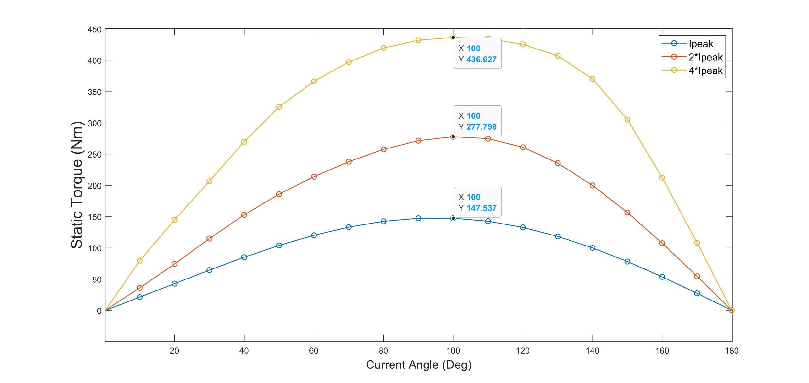

Figure 9: Static Torque Response

We have analyzed the various factors of machine such as flux distributions along the airgap, current angles when the torque is maximum etc. Now, for the sensitivity analysis of machine designed, we must analyze the other factors such as Torque Ripples, Cogging Torque, Losses etc.

The torque ripples are produced in electrical machine dure to the magnetomotive forces produced by the stator current and the harmonics produced due to rotor geometry when machine is loaded. It is basically due to the interactions between the PM field and $mmf$ harmonics due to stator currents and their distributions. These values are greatly affected by the machine geometry. The torque ripples are measured in terms of percentage and is given by,

$$T_{ripple}\%= \frac{T_{max} -T_{min}}{T_{avg}}×100\%$$

Where $T_{max}$, $T_{min}$& $T_{avg}$ are the maximum torque, minimum torque and the average torque produced by the machine within the requested range of operation. The main effects of the torque ripples are noise, vibrations, and the current distortions etc. As mentioned above, the torque ripples are majorly dependent on the machine geometry. On the other hand, the cogging torque is the torque produced by the machine in no-load condition when there is an angular movement of the rotor. It is basically due to the interactions between the Permanent Magnets (PMs) and the stator slot openings. The frequency and magnitude of the cogging torque depends on the slot pole combinations and the magnitude of the PM flux. For identical spaced PM poles, the total cogging torque periods (Np) for a slot pitch movement is given by,

$$Np=\frac{2p}{GCD(Z,2p)}$$

Where p is the pole pairs and Z is the total number of slots. For the machine I am analyzing in this coursework, the pole pair number is 4 and number of slots are 72. In other way, because of symmetry, the ripple period can be calculated with $Te/6$, where $Te$ is given by ${360}^{°}/p$. This gives the ripple period of my machine as ${15}^{°}$ **mechanical.** The some of the various ways of minimizing the cogging torque include better **slot-pole combination**, **magnet span** determination, **rotor skewing** etc.

The various other methods to reduce torque ripples and cogging torque can be analyzed. A novel method to reduce the cogging torque and to suppress torque ripples effectively using **tooth notching pairing** is explained in this paper [21]. This helps in maintaining the symmetrical back EMF and balanced axial force using uniformly distributed notching. Also, these values can be significantly brought down by analyzing the effect of **manufacturing tolerances**, **armature reaction**, and **stator slot opening** on terms like airgap flux density, back emf, electromagnetic torque and cogging torque [6]. The cogging torques can be significantly reduced by choosing properly the **depth of added dummy slots** in stator core and the **flux gap width** [18]. The magnet shifting and carefully optimizing the magnet arc can bring down the cogging torque significantly. The **tolerances in magnet positioning** affects the cogging torque [16, 17]. The cogging torque and **acoustic noise** can be reduced by effectively placing the **rubber magnets** in between the airgaps [19]. The **slot opening width** affects the airgap magnetic field distribution. So, we should carefully **optimize** the slot opening width [22]. Moreover, the cogging torque can be reduced by selecting the optimal groove location for all stator wedges [7]. The **tooth-tip** and slot opening mainly determines the torque ripples and cogging torque [12, 13]. Another way of reducing the torque ripples is by **chamfering the corner of tooth-tips**. Torque ripple decreases with increase in chamfered quantity [23]. We can intelligently select he **slot-pole combination** in order to have the machine for particular application with lower values of cogging torque and torque ripples [24]. The **permanent magnet length and width**, **airgap length** should be carefully selected as varying these values significantly affects the torque ripples. There is always optimal values for these quantities [11, 15]. The **Bread-Loaf magnets** and **Halbach Magnets** system can significantly reduce the cogging torque [25, 26].

As discussed above in certain applications such as **Aerospace applications** like aircraft actuation systems, **low speed drives**, **Automotive applications** like electric vehicles, the values of torque ripples and cogging torque should be minimized. For aerospace application, these values should be as less as than **1.5%** whereas for electric vehicles applications, we are good if these values are within **3-4%.** In this coursework, I am analyzing the torque ripples & cogging torque in the designed machine and trying to minimize them to find the optimized machine parameters while playing with some of the machine geometry parameters.

**Tooth Width (Wt)** plays an important role in determining the ripples and cogging torque as already discussed above. When varying the Wt keeping all other machine parameters same as initial values, the results obtained are as shown below in figure 10 & 11. The x-axis is the **rotor position in mechanical degrees** where rotor is moved from zero to the maximum of 15 degrees.

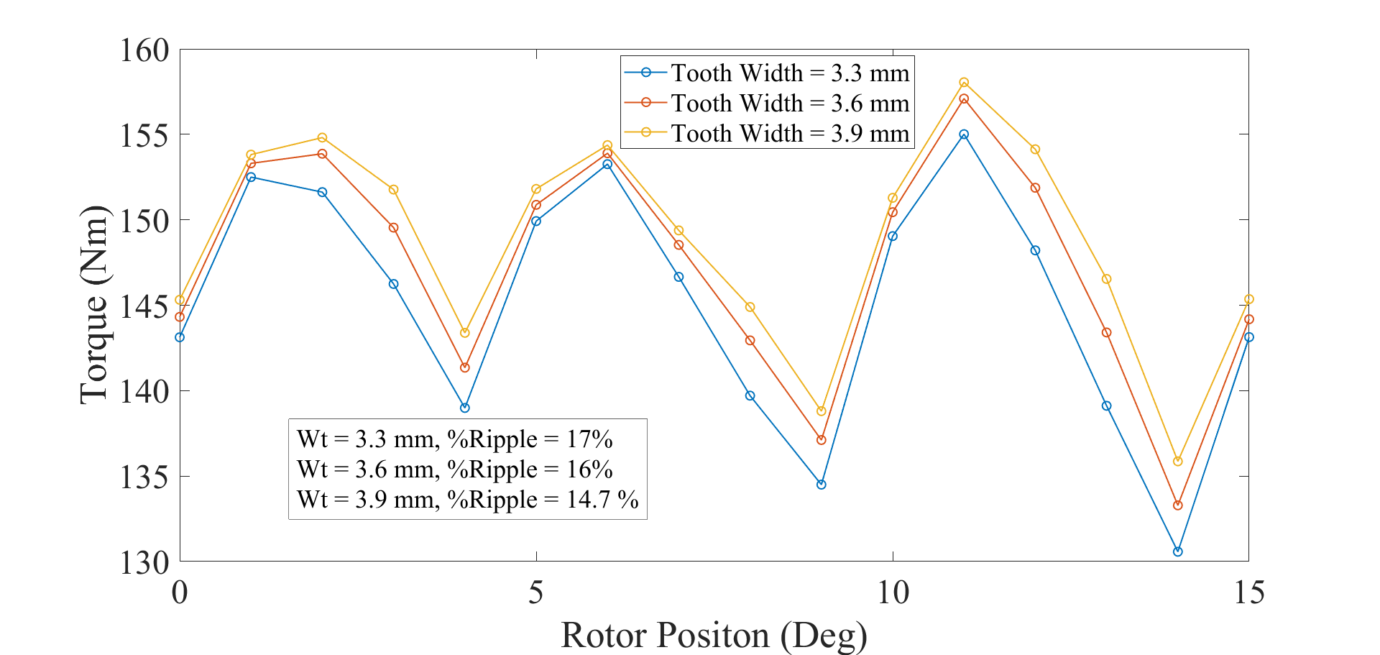

Figure 10: Effect of Variation of Tooth Width on Torque Ripples

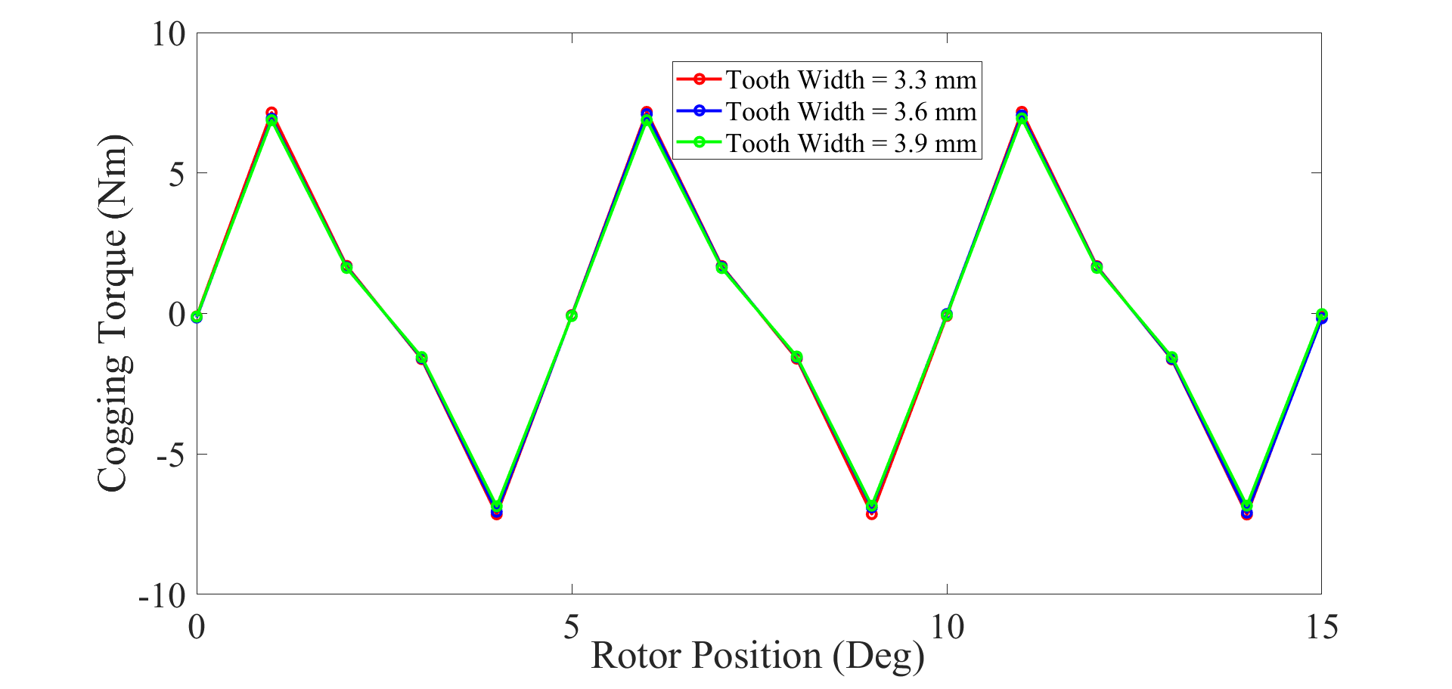

Figure 11: Effect of Variation of Tooth Width on Cogging Torque

Here we can confirm that the tooth width helps in determining the torque ripples. As we can see, the **torque ripples have reduced when we increase the width of tooth.** The **average value of toque has also increased**.This **does not affect much on the cogging torque** as there is not much reduction when we increase the tooth width. So, we should carefully decide the width of tooth as there is always an **optimal parameter value**.

The other obvious parameter to vary is the **Slot Opening Width (WSO)**. The results obtained while varying the WSO are shown below in figures 12 & 13. Slot Opening Width greatly influences both torque ripples and the cogging torque. As we can see, **both the torque ripples and the cogging torque have reduced when increased the value of WSO.** The average torque values have also increased. The optimal value of WSO should be chosen which meets the desired specifications.

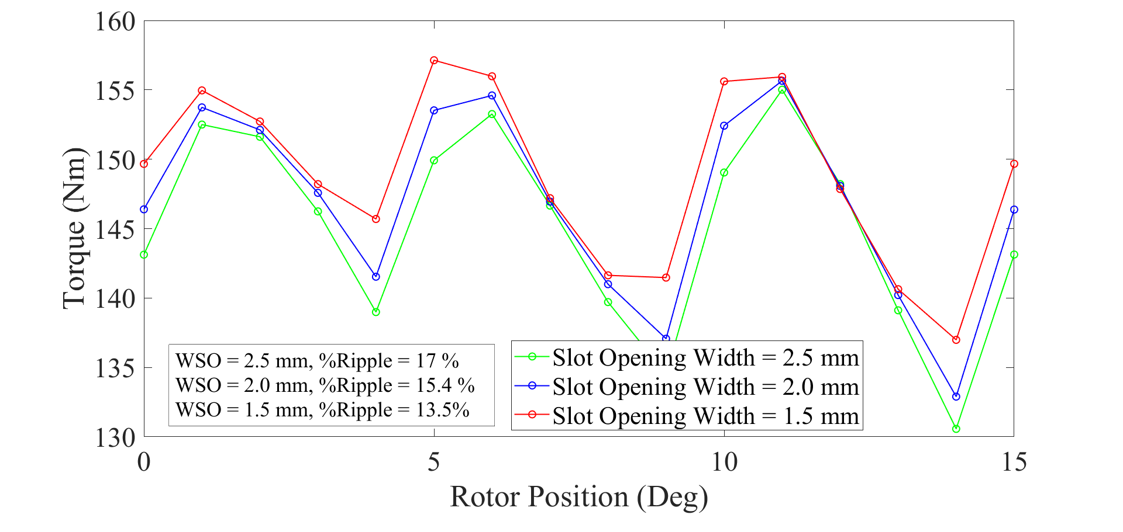

Figure 12: Effect of Variation of Slot Opening Width on Torque Ripples

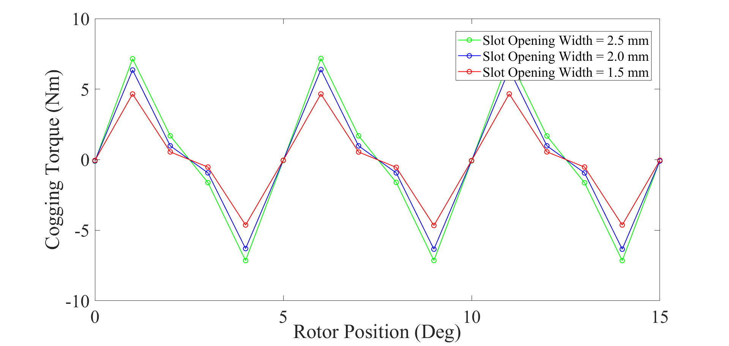

Figure 13: Effect of Variation of Slot Opening Width on Cogging Torque

As already mentioned above, the **magnet pole span (PPM)** also plays important role in determining the machine performance. When varying the magnet pole span while keeping all other parameters same as initial, the results obtained are as shown below in figures 14 & 15. As seen from the figures, **the ripples and cogging torque may increase or decrease when we increase the magnet pole span.** It **really depends on the other machine parameters** as the mid axis of the permanent magnet varies when we vary other parameters. This is because the **PM interacts with the stator slots**. There is always an **optimal value** of ppm for a particular machine design and should be analyzed in detail while selecting it. As said earlier, it is a **trade-off between these ripples and average torque**. We should carefully select the magnet pole span ratio that gives less ripples and still gives the reasonable mean torque. As seen from the cogging torque response, there is a **significant reduction in the value** when properly selecting the magnet pole span value.

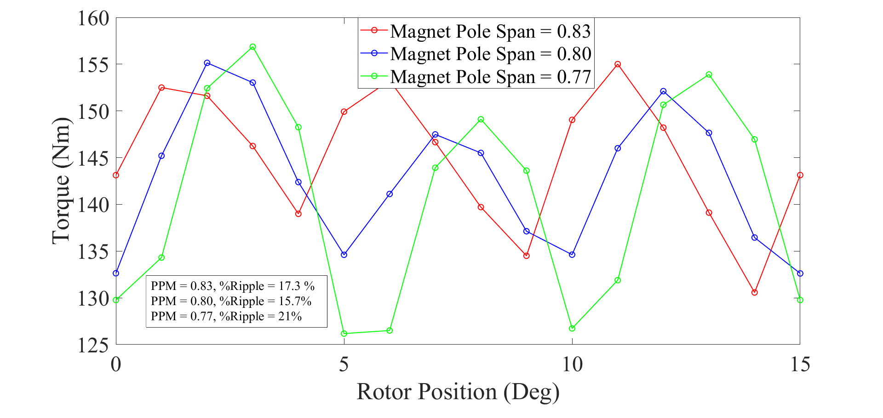

Figure 14: Effect of Variation of Magnet Pole Span on Torque Ripples

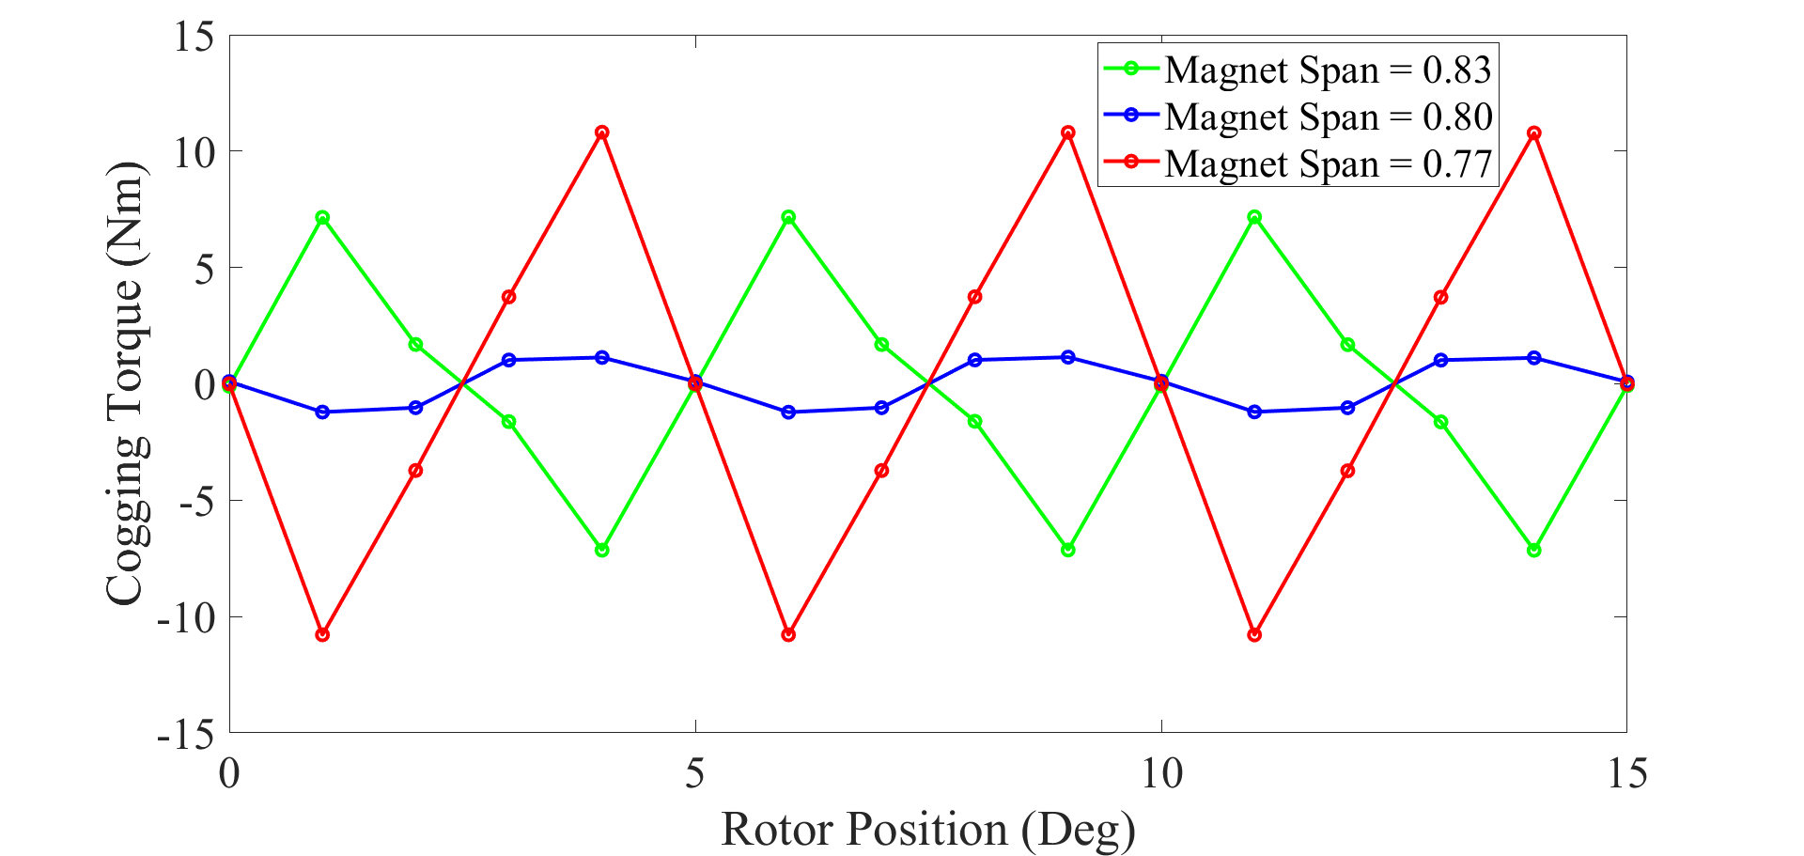

Figure 15:Effect of Variation of Magnet Pole Span on Cogging Torque

From the various examinations done above, the optimal values for the designed machine are chosen which improves the overall performance of the machine. **The optimal values are chosen solely to reduce the torque ripples, cogging torque, machine losses and to improve the harmonics in the airgap flux distributions.** The Table 2 below shows the parameters chosen for optimal characteristics of the machine.

Apart from the tooth width, slot opening width, and magnet span, I found that the **various other** **factors like slot opening height, wedge height, PM thickness, airgap length, fill factor** etc. play very important role in determining the overall performance of the machine. In 2D FEA, we **cannot consider the terms like rotor skewing, end winding leakages, magnet positioning** etc. but these terms also have influence in smoothening the machine performance. As machine geometry affects the distribution of flux lines across the machine, we should always choose the optimal parameters for our machine that can deliver us the desired specifications. **For the machine I studied, I have chosen the following parameters for my machine which I found that gives better overall performance compared to the initial one.**

Table 2: Optimized Motors Parameters

|  |  |
| --- | --- |
| **Motor Parameters** | **Values** |
| Tooth Width | 3.9 mm |
| Slot Opening Height | 0.6 mm |
| Slot Opening Width | 1.1 mm |
| Wedge Height | 0.4 mm |
| Airgap Length | 1.2 mm |
| PM Thickness | 2.0 mm |
| PM Span | 0.8 mm |
| Filling Factor | 0.50 |

I tried to compare the results using the optimized parameters and the one obtained using the initial parameters in terms of torque ripples and the cogging torque. The comparisons are as shown below in figures 16 and 17. As clearly seen, I have been able to optimize my machine parameters and bring down the value of ripple percentage from initial 17% to 7.4%. This is a significant improvement where the ripple percentage have been **reduced by 54%.** Also, the average value of torque produced by the machine increased **from 147 Nm at initial to 149.5 Nm with optimized parameters**. This **value is 99% of machine’s rated torque value**. Therefore, I can say that **the efficiency of the machine has been improved significantly**.

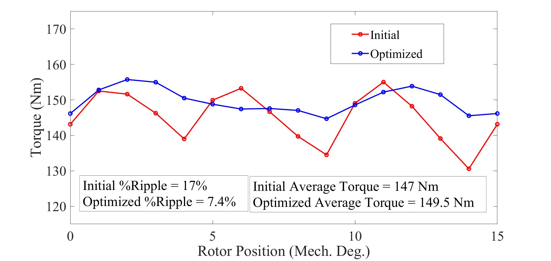

Figure 16: The Comparison of Torque Ripples

As seen in figure below, with optimized machine parameters values, I have been able to bring the cogging torque from **initial peak of 7.15 Nm** to **optimized peak of 0.38 Nm**. This is a massive reduction in terms of cogging torque value. I believe, by carefully selecting the **magnet pole span, magnet thickness, magnet position and airgap length**, we should be able to bring down the cogging torque value to **almost zero**.

The airgap normal flux density plot of machine with optimized parameters is as shown is figure 18. The figure 19 shows the flux lines distribution in the machine with optimized parameters in no-load condition. Compared to the initial parameter’s airgap flux density plot, this is **smoother**. I can say that the optimized parameters have **less harmonics in the airgap flux distribution**. The **iron core is less saturated** with optimized parameters values compared to the initial values.

The overall accuracy and performance of the machine using Finite Element Analysis is basically **a trade-off with the simulation time**. As these simulations are computationally time demanding, we should find a suitable agreement.

The sensitivity analysis can be extended further for detail examinations using **3D FEA**, where we can study various rotor skewing, magnet positioning, end winding leakage fields etc. to design the optimal parameters for the machine [4]. The torque performance improvement and reduction of torque ripples can be done by adopting various generic algorithms (**GA**), use of soft magnetic alloys (**SMA**) etc.[20].

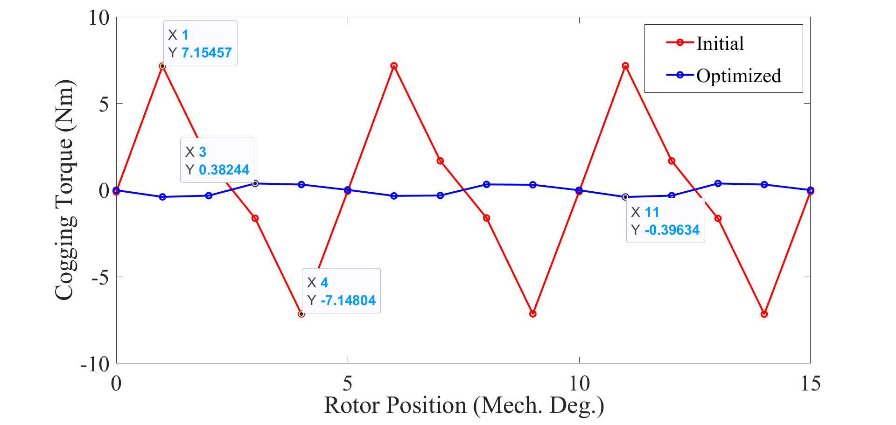

Figure 17: The Comparison of Cogging Torque

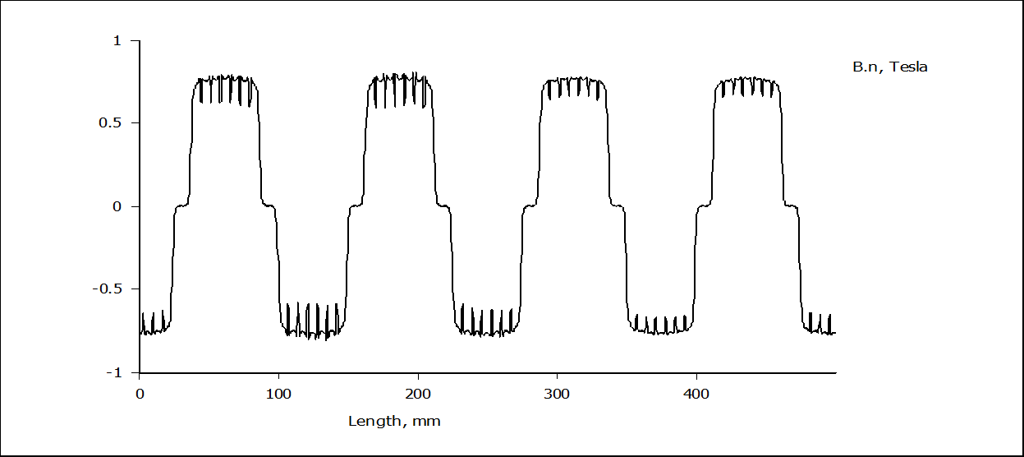

Figure 18: The Airgap Normal Flux Density Distribution (No-Load) with Optimized Parameter Values

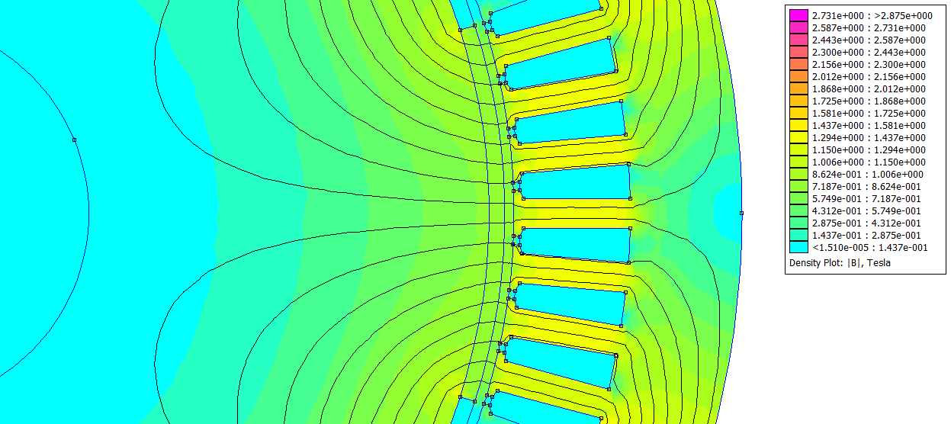

Figure 19: Flux Lines Distribution and Flux Density Plot (No-Load) from femm4.2 With Optimized Parameters

# Conclusion

In this coursework, the sensitivity analysis of a SPM motor is performed. The various terms like airgap flux density, torque ripples, cogging torque and losses have been studied and motor parameters have been optimized to minimize the effects and maximize the overall machine performance. A tradeoff between the simulation time and machine’s accuracy is adopted. It has been found that the torque ripples and cogging torque are highly dependent in the machine’s geometry (stator and rotor geometry) and can be varied accordingly. The effect of variations of the tooth width, slot opening width, magnet span has been studied. Increasing tooth-width and decreasing slot opening width reduced the torque ripples and cogging torque. Cogging torque can be brought down to a very small value by suitably defining the positioning of the magnet and optimization of magnet arc. The variation of airgap length also varies the nature of magnetic field distribution so does the variation of slot opening width. The wedge height and slot opening height can be optimized accordingly to define the machine’s performance. The height of the PM and the size of the machine also affects the torque ripples. The dimensions of PM have more effects on torque ripples for small size motors. The best performance of the machine is achieved when the PM height is equal to 2 mm and pole span is equal to 0.8. With optimal parameters selected, the torque ripples have been reduced by 54 % and cogging torque almost to zero compared to the initial parameters. The various other methods using 3D FEA can be adopted for further examinations on the sensitivity of the machine where the terms like, notching pairing, end winding leakages, rotor skewing, chamfering the corners of tooth-tips etc. can be studied. The better slot-pole combinations also can be studied to determine the optimal design specifications.

# References

[1] S. Vaschetto, A. Tenconi, and G. Bramerdorfer, "Sizing procedure of surface mounted PM machines for fast analytical evaluations," in *2017 IEEE International Electric Machines and Drives Conference (IEMDC)*, 21-24 May 2017 2017, pp. 1-8, doi: 10.1109/IEMDC.2017.8002223.

[2] F. Marignetti, M. A. Darmani, and S. M. Mirimani, "Electromagnetic sizing of axial-field flux switching permanent magnet machine," in *IECON 2016 - 42nd Annual Conference of the IEEE Industrial Electronics Society*, 23-26 Oct. 2016 2016, pp. 1624-1628, doi: 10.1109/IECON.2016.7793175.

[3] S. Vaschetto, G. Bramerdorfer, A. Cavagnino, and A. Tenconi, "Analytically-Based Optimization of SMPM Machines for Sizing Validation Purposes," in *2019 IEEE International Electric Machines & Drives Conference (IEMDC)*, 12-15 May 2019 2019, pp. 1433-1438, doi: 10.1109/IEMDC.2019.8785195.

[4] L. Xu, Y. Xu, J. Xu, B. Wang, and F. Xin, "Optimal design and electromagnetic analysis of yokeless and segmented armature machine based on finite-element method and genetic algorithm," in *2017 IEEE Transportation Electrification Conference and Expo, Asia-Pacific (ITEC Asia-Pacific)*, 7-10 Aug. 2017 2017, pp. 1-6, doi: 10.1109/ITEC-AP.2017.8080983.

[5] S. Hlioui, L. Vido, Y. Amara, M. Gabsi, A. Miraoui, and M. Lecrivain, "Design of a synchronous machine with concentric stator windings and permanent magnets in focusing configuration," in *2007 International Aegean Conference on Electrical Machines and Power Electronics*, 10-12 Sept. 2007 2007, pp. 507-512, doi: 10.1109/ACEMP.2007.4510554.

[6] B. Nanda and P. Kumar, "Analytical Model of Surface Mounted Permanent Magnet Motor for Sensitivity Analysis under Manufacturing Tolerances," in *2018 IEEE Power & Energy Society General Meeting (PESGM)*, 5-10 Aug. 2018 2018, pp. 1-5, doi: 10.1109/PESGM.2018.8586193.

[7] A. Tessarolo, L. Branz, and M. Mezzarobba, "Optimization of a SPM machine using a non-isotropic magnetic wedge with an analytical method for cogging torque estimation," in *2016 XXII International Conference on Electrical Machines (ICEM)*, 4-7 Sept. 2016 2016, pp. 1970-1975, doi: 10.1109/ICELMACH.2016.7732793.

[8] P. Lazari, J. Wang, and L. Chen, "A Computationally Efficient Design Technique for Electric-Vehicle Traction Machines," *IEEE Transactions on Industry Applications,* vol. 50, no. 5, pp. 3203-3213, 2014, doi: 10.1109/TIA.2014.2304619.

[9] M. Degano, E. Carraro, and N. Bianchi, "Selection Criteria and Robust Optimization of a Traction PM-Assisted Synchronous Reluctance Motor," *IEEE Transactions on Industry Applications,* vol. 51, no. 6, pp. 4383-4391, 2015, doi: 10.1109/TIA.2015.2443091.

[10] F. Khan, E. Sulaiman, M. Z. Ahmad, and H. Ali, "Design Refinement and Performance Analysis of 12Slot-8Pole Wound Field Salient Rotor Switched-Flux Machine for Hybrid Electric Vehicles," in *2014 12th International Conference on Frontiers of Information Technology*, 17-19 Dec. 2014 2014, pp. 197-201, doi: 10.1109/FIT.2014.45.

[11] P. Li, W. Ding, and G. Liu, "Sensitivity Analysis and Design of a High Performance Permanent-Magnet-Assisted Synchronous Reluctance Motor for EV Application," in *2018 IEEE Transportation Electrification Conference and Expo (ITEC)*, 13-15 June 2018 2018, pp. 406-411, doi: 10.1109/ITEC.2018.8450176.

[12] W. Ren, Q. Xu, Q. Li, and L. Zhou, "Reduction of Cogging Torque and Torque Ripple in Interior PM Machines With Asymmetrical V-Type Rotor Design," *IEEE Transactions on Magnetics,* vol. 52, no. 7, pp. 1-5, 2016, doi: 10.1109/TMAG.2016.2530840.

[13] D. Wu and Z. Q. Zhu, "Design Tradeoff Between Cogging Torque and Torque Ripple in Fractional Slot Surface-Mounted Permanent Magnet Machines," *IEEE Transactions on Magnetics,* vol. 51, no. 11, pp. 1-4, 2015, doi: 10.1109/TMAG.2015.2436714.

[14] N. Schofield and C. Giraud-Audine, "Design procedure for brushless PM traction machines for electric vehicle applications," in *IEEE International Conference on Electric Machines and Drives, 2005.*, 15-15 May 2005 2005, pp. 1788-1792, doi: 10.1109/IEMDC.2005.195962.

[15] N. Bianchi, M. Degano, and E. Fornasiero, "Sensitivity Analysis of Torque Ripple Reduction of Synchronous Reluctance and Interior PM Motors," *IEEE Transactions on Industry Applications,* vol. 51, no. 1, pp. 187-195, 2015, doi: 10.1109/TIA.2014.2327143.

[16] G. Bramerdorfer, E. Marth, and G. Goldbeck, "Cogging torque sensitivity considering imperfect magnet positioning for permanent magnet machines of different slot and pole count," *CES Transactions on Electrical Machines and Systems,* vol. 4, no. 3, pp. 243-251, 2020, doi: 10.30941/CESTEMS.2020.00030.

[17] L. Dosiek and P. Pillay, "Cogging Torque Reduction in Permanent Magnet Machines," *IEEE Transactions on Industry Applications,* vol. 43, no. 6, pp. 1565-1571, 2007, doi: 10.1109/TIA.2007.908160.

[18] G. J. Li, B. Ren, and Z. Q. Zhu, "Cogging torque and torque ripple reduction of modular permanent magnet machines," in *2016 XXII International Conference on Electrical Machines (ICEM)*, 4-7 Sept. 2016 2016, pp. 193-199, doi: 10.1109/ICELMACH.2016.7732526.

[19] J. Song, S. Sung, and G. Jang, "Effect of air gap between PM segments on cogging torque and acoustic noise of BLDC motor," in *2015 IEEE International Magnetics Conference (INTERMAG)*, 11-15 May 2015 2015, pp. 1-1, doi: 10.1109/INTMAG.2015.7157401.

[20] H. Yu, G. Yu, Y. Xu, and J. Zou, "Torque Performance Improvement for Slotted Limited-Angle Torque Motors by Combined SMA Application and GA Optimization," *IEEE Transactions on Magnetics,* vol. 57, no. 2, pp. 1-5, 2021, doi: 10.1109/TMAG.2020.3006126.

[21] W. Ren and Q. Xu, "A novel technique of cogging torque reduction in mass-produced surface-mounted permanent magnet motor using tooth notching pairing," in *2015 IEEE International Magnetics Conference (INTERMAG)*, 11-15 May 2015 2015, pp. 1-1, doi: 10.1109/INTMAG.2015.7157406.

[22] Y. Han, S. Chen, C. Gao, M. Gao, J. Si, and Y. Hu, "Effect of slot opening width on the air-gap magnetic field of a direct drive permanent magnet motor," *Applied Sciences,* vol. 9, no. 21, p. 4649, 2019.

[23] N. Soda and M. Enokizono, "Relation Between Stator Core Shape and Torque Ripple for SPM Motor," in *2018 XIII International Conference on Electrical Machines (ICEM)*, 3-6 Sept. 2018 2018, pp. 955-960, doi: 10.1109/ICELMACH.2018.8507050.

[24] L. Guo and H. Wang, "Research on Stator Slot and Rotor Pole Combination and Pole Arc Coefficient in a Surface-Mounted Permanent Magnet Machine by the Finite Element Method," *World Electric Vehicle Journal,* vol. 12, no. 1, p. 26, 2021.

[25] R. Nasiri-Zarandi, A. Ghaheri, and K. Abbaszadeh, "Cogging Torque Reduction in U-Core TFPM Generator Using Different Halbach-Array Structures," in *2018 International Symposium on Power Electronics, Electrical Drives, Automation and Motion (SPEEDAM)*, 20-22 June 2018 2018, pp. 1153-1158, doi: 10.1109/SPEEDAM.2018.8445328.

[26] S. Zhu, W. Zhao, J. Ji, G. Liu, Y. Mao, and T. Liu, "Investigation of Bread-Loaf Magnet on Vibration Performance in FSCW PMSM Considering Force Modulation Effect," *IEEE Transactions on Transportation Electrification,* pp. 1-1, 2020, doi: 10.1109/TTE.2020.3035180.